**→ Gaussian filter :**

1. **Read our image and convert it into floting point value :**

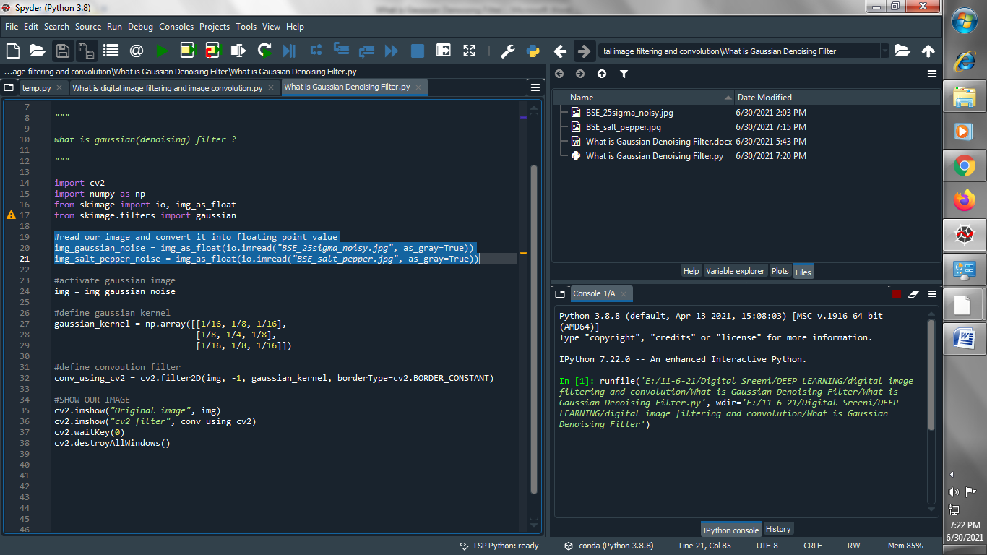

1. **Activate Gaussian filter**

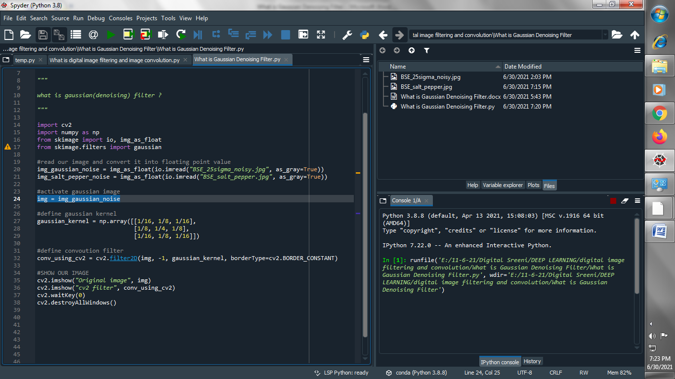

1. **Define Gaussian filter**

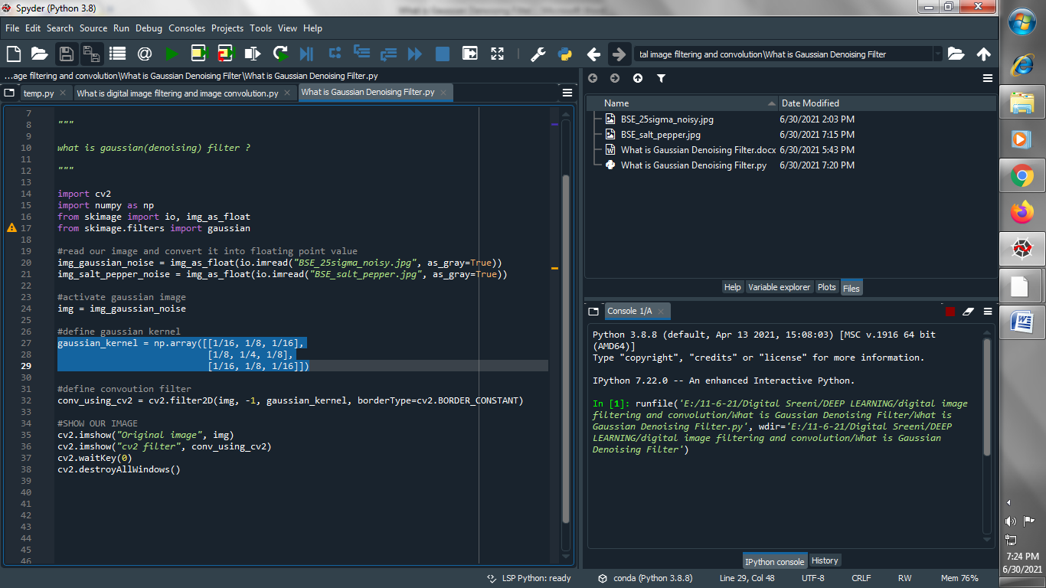

1. **Define convolution filter :**

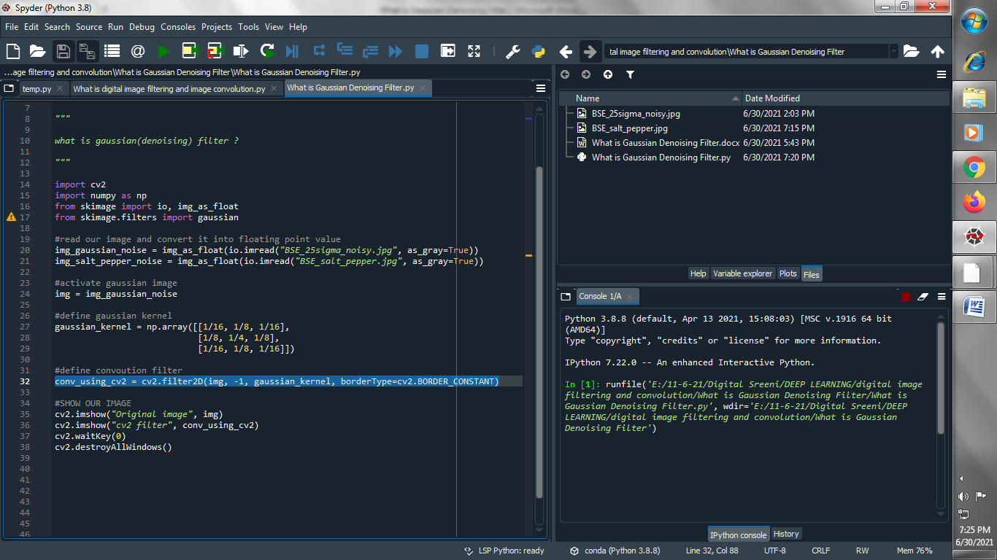

1. **Show our image :**

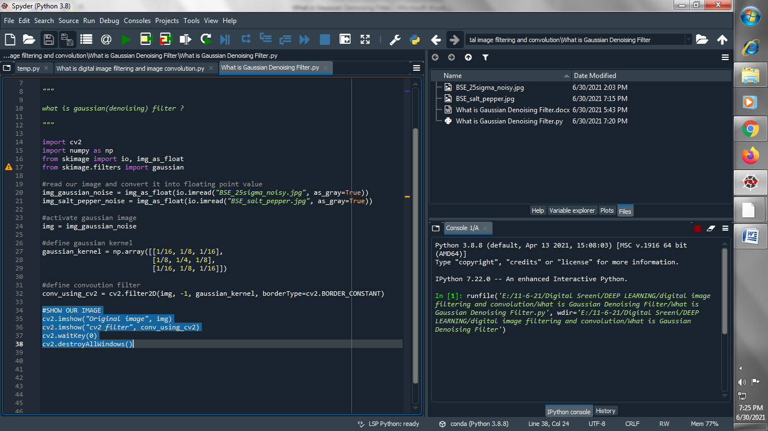

**Output :**

**Original image :**

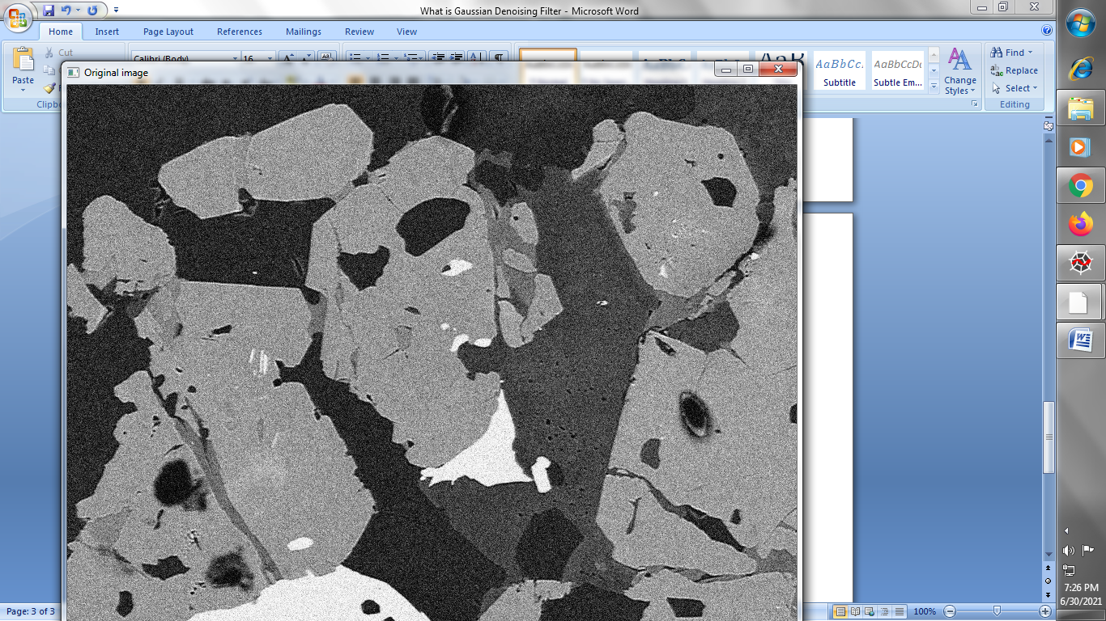

**Gaussian filter image :**

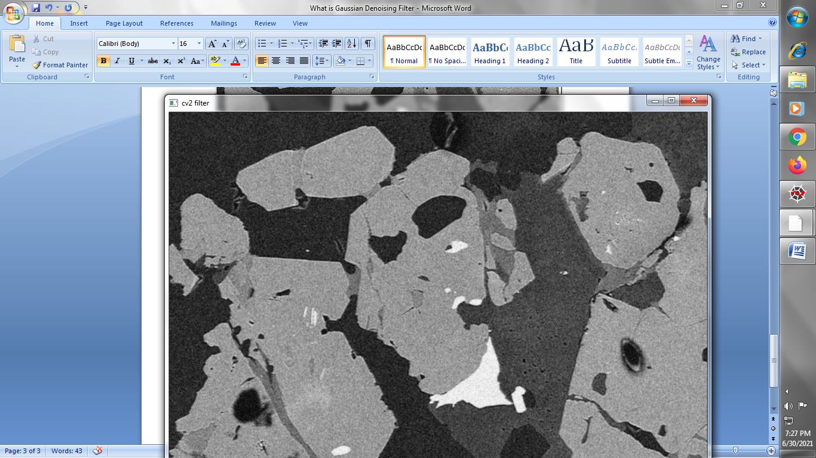

**→ Easy way for applying Gaussian filter using opencv:**

1. **Read our images and convert it into floating point value**

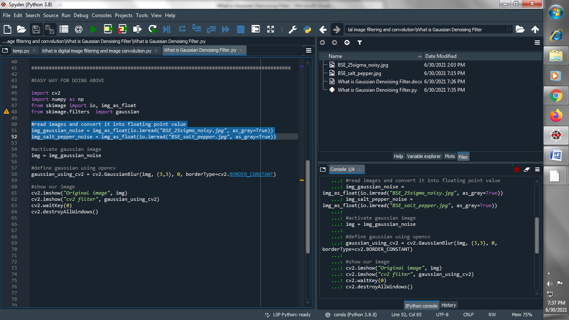

1. **Activate Gaussian image**

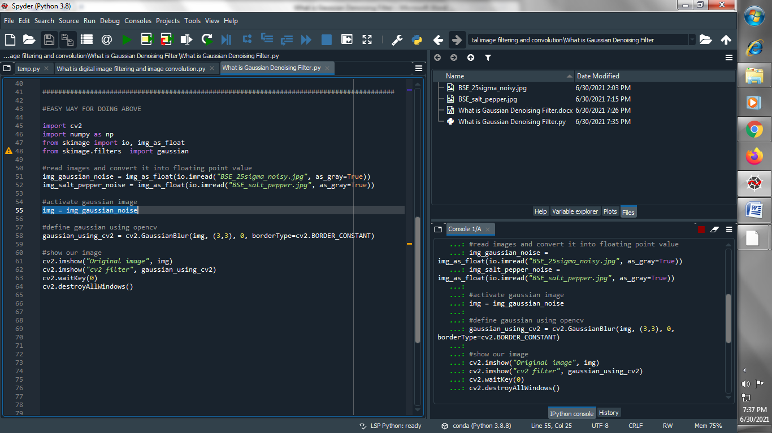

1. **Define Gaussian filter using opencv**

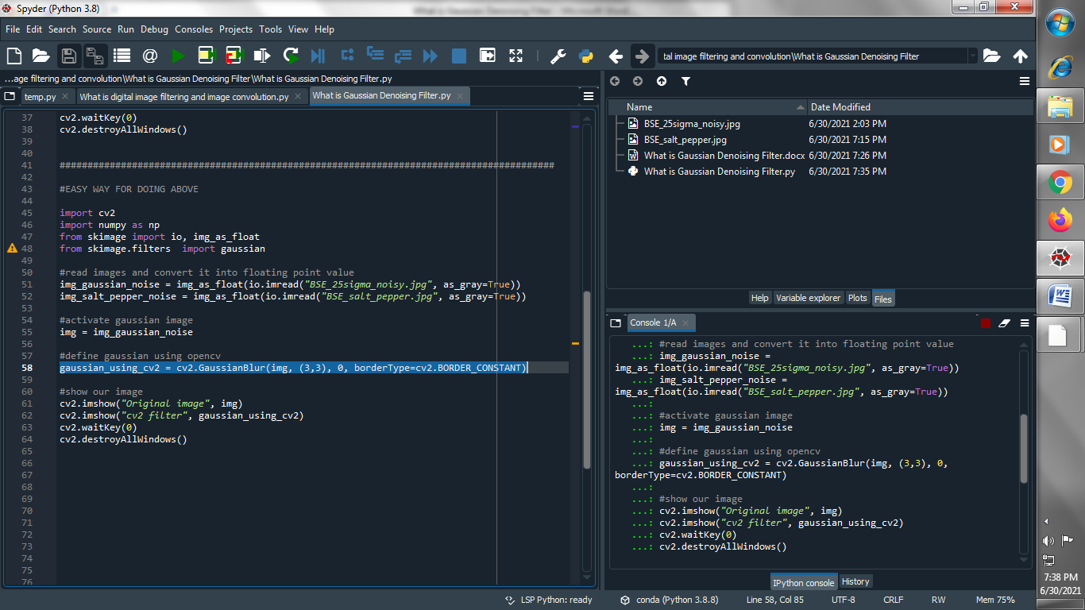

1. **Show our image**

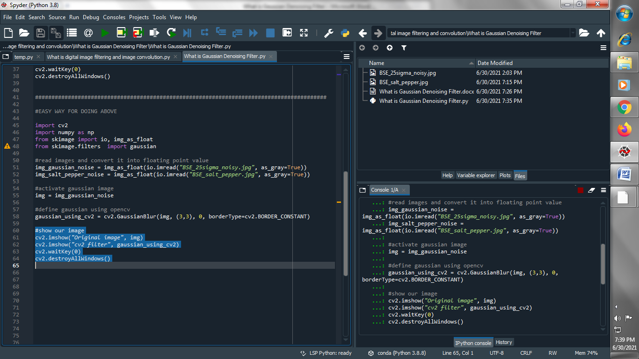

**Output :**

**Original image :**

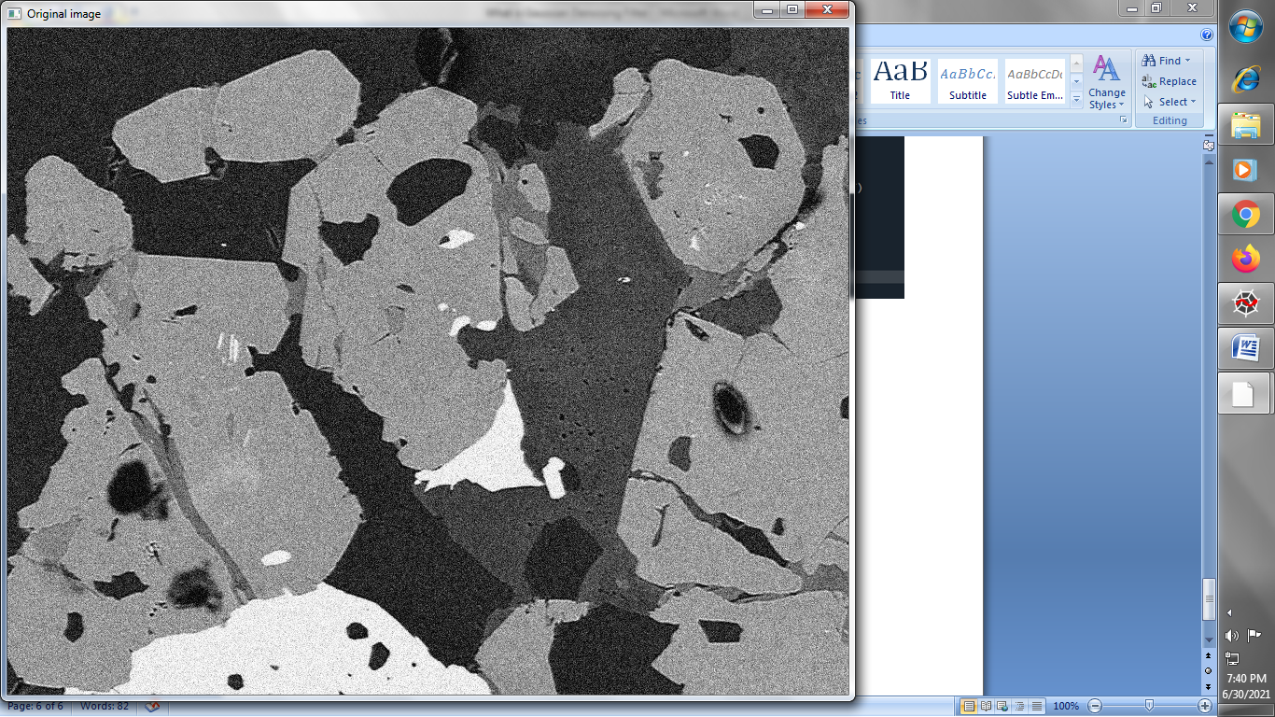

**Gaussian filtered image using opencv :**

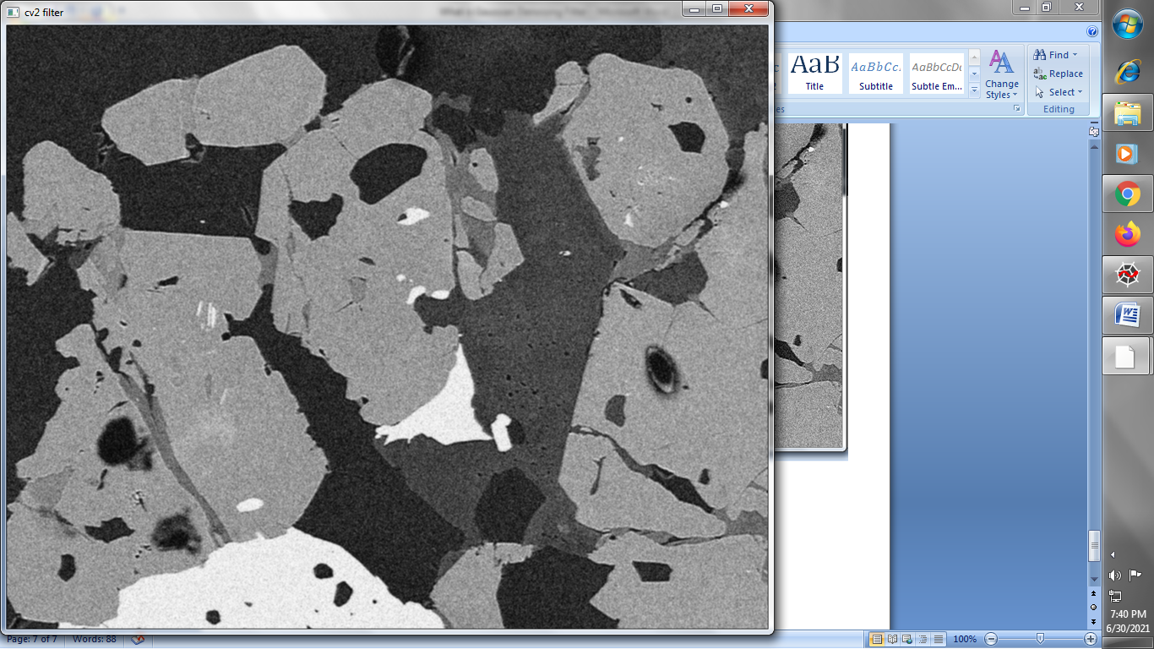

**→ Another way of doing it is using skimage :**

1. **Read our image and convert it into floating point value :**

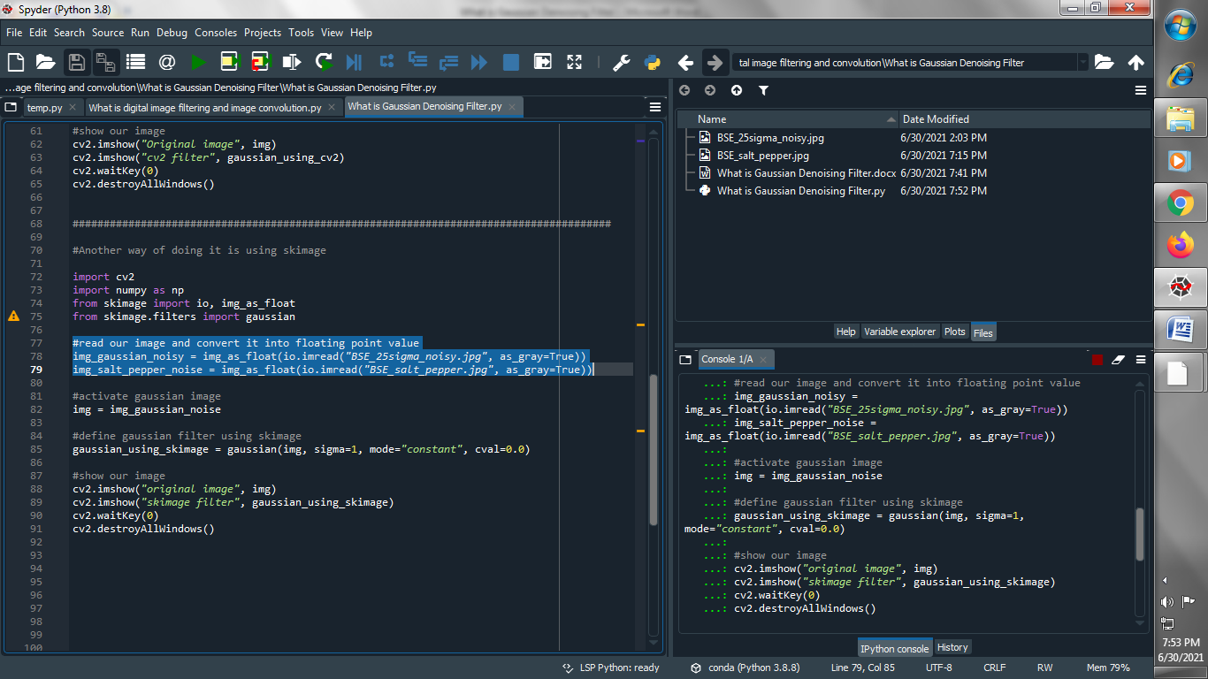

1. **Activate Gaussian image :**



1. **Define Gaussian filter using skimage :**

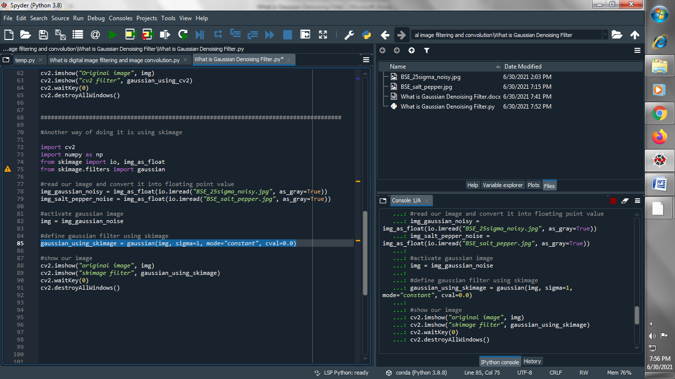

1. **Show our image**

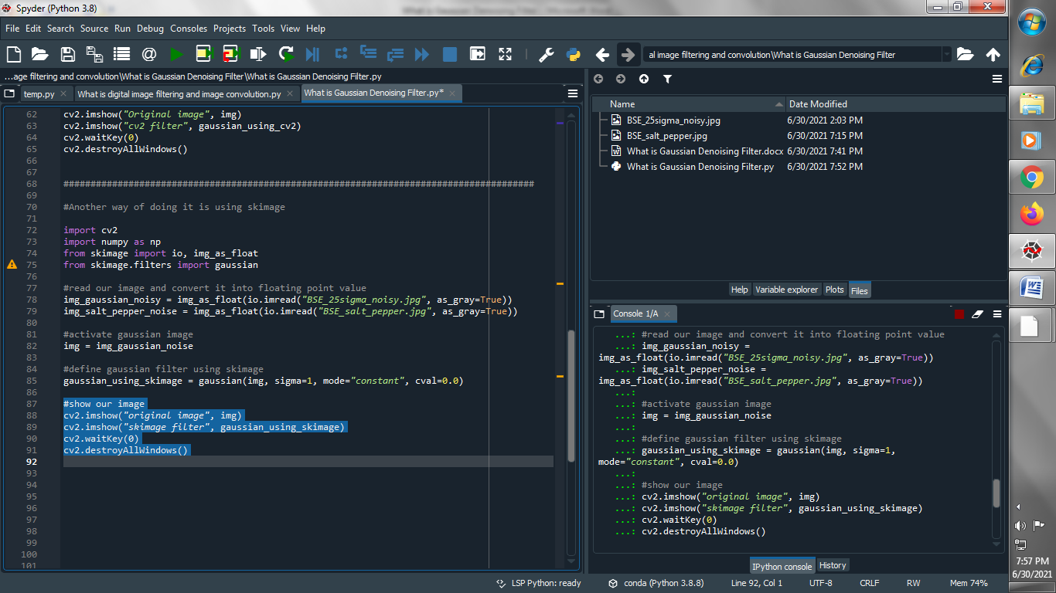

**Output :**

**Original image :**

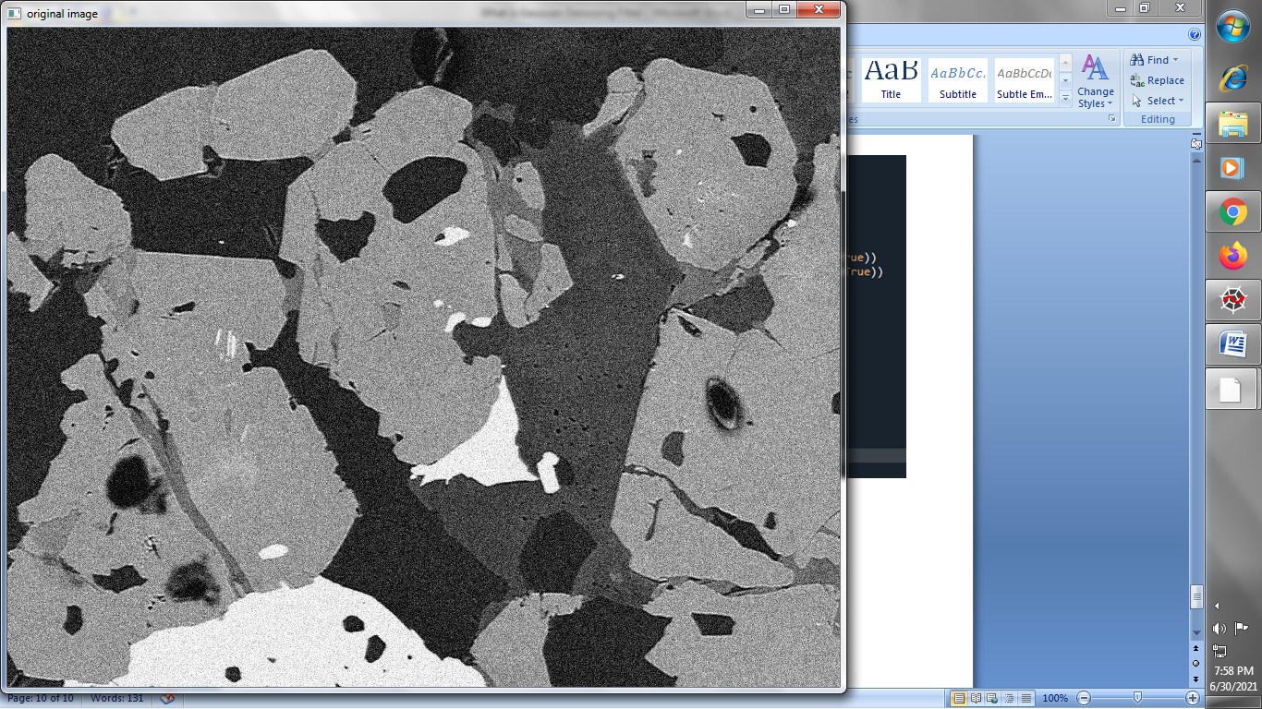

**Gaussian filtered image using skimage :**

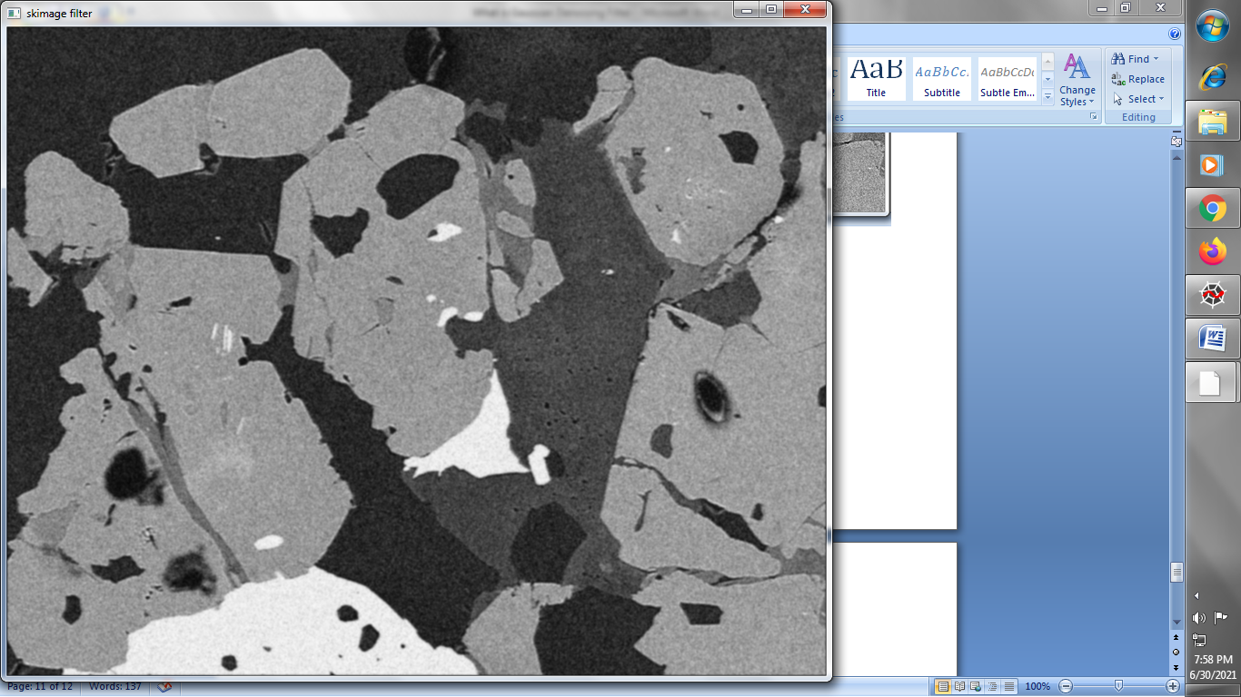

**→ Let’s see the result of salt pepper noisy image**

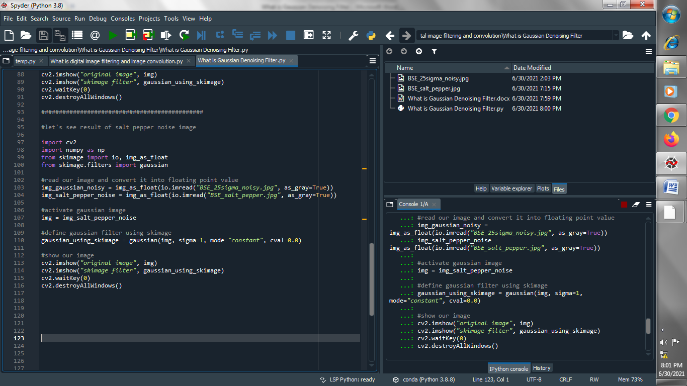

**Output :**

**Original image :**

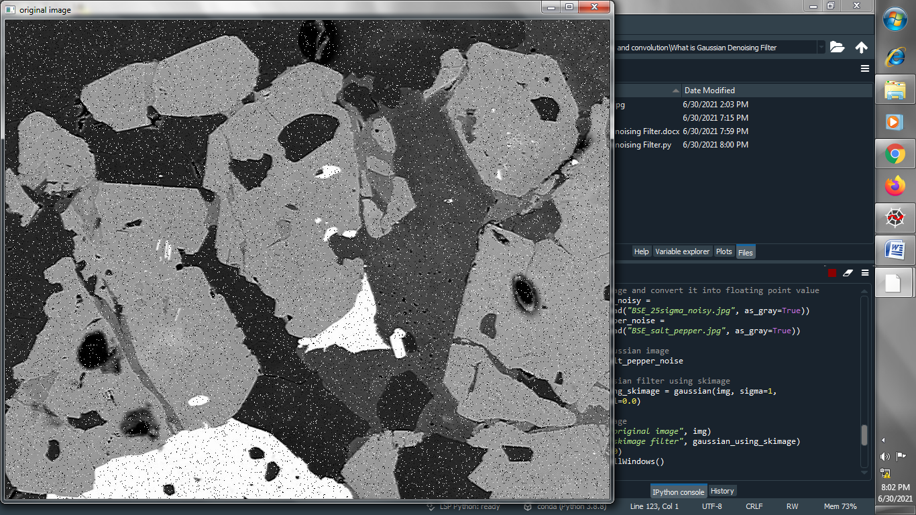

**Gaussian filter image :**

